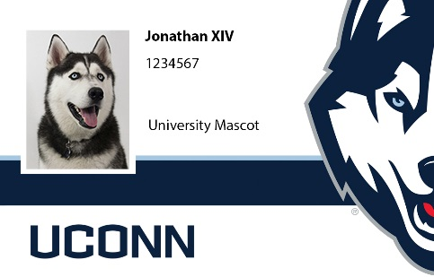
Husky One Card (Your UConn ID card)
  - One Card Office, Student Union, Room 228
  - Office Hours: *Currently by appointment only
  - Monday – Friday from 8am to 4pm
Website: onecard.uconn.edu

To obtain your UConn Husky One Card, please send a detailed email to onecard@uconn.edu including your name, PeopleSoft Number or NetID, and your home mailing address so that the One Card Office can mail your One Card accordingly. Or you may make an appointment at onecard.uconn.edu to pick up your One Card in-person at the Storrs Campus.

Friday, August 27th, the One Card Office will have extended business hours of 8am to 6pm for Move-In weekend. You can also visit the office by appointment only on Saturday, August 28th from 12pm to 4pm and Sunday, August 29th from 10am to 2pm.

Please note: August 16th through September 10th will be an especially busy time as patrons return to campus. Please remember to schedule an appointment ahead of time once you have successfully uploaded your photo documentation.

Helpful Tips
What do I need to have with me to get a Faculty Husky One Card?
Your Husky One Card can be obtained AFTER you receive your Net ID. Please bring a government photo ID (such as a driver’s license, military ID or passport) and a copy of your employment offer letter. Your initial card is free.

How do I obtain my Husky One Card if I work at a regional campus?
Employees may request their One Card to be mailed to their home address by sending an email to onecard@uconn.edu including their name, PeopleSoft number/NetID and the appropriate mailing address. Employees may also make an appointment at onecard.uconn.edu to pick up their One Card in person at the Storrs campus.

How do I get my Husky One Card to open the door of the building I work in?
You will be issued a smartcard. If the building you work in has proximity readers on the exterior doors, you will need to give the five-digit proximity number found on the back bottom right corner of your card to your building door access manager so it can be registered into the door access system.

What do I do if I lose my Husky One Card?
If you lose your card, go to www.onecard.uconn.edu and click on “Report Lost Card” under Quick Links. If you find it, you can reactivate it at the same link. The fee to replace a lost card is $30.

What happens if my Husky One Card stops working?
Please bring it to the One Card Office. We will replace a non-functioning card that exhibits normal wear and tear at no charge. Please do not punch a hole in your card.

Does my Husky One Card expire?
Your card is valid if you are affiliated with the University. If there is a change in status (such as a name change) you can get a new card for free.

Can another person use my card?
No. Your card is only for your use. Since your card may grant you access to specific buildings and labs, it would be a security violation to share your card with others. Additionally, this policy safeguards any value, such as Husky Bucks, that may be on your card.

What can I use my card for?
The Husky One Card has many different functions. In addition to using it for identification, you will use it to take materials out of the library, to access the recreational facility (with a purchased membership), to access buildings and labs, to make purchases with Husky Bucks, and for meal plans. Food and beverages purchased at UConn Dining Services’ locations are tax-exempt when you present your card to the cashier.

What are Husky Bucks?
Husky Bucks is a debit-like account set up on your Husky One Card. You will enjoy the convenience of being able to make purchases at participating locations, on and off campus, without having to carry cash or other cards. Many merchants offer discounts and promotions just by using Husky Bucks or simply by showing your UConn One Card, however it is up to their discretion to provide such discounts and run such promotions. For the full list go to www.onecard.uconn.edu. Follow us on Twitter and Facebook to see any updates!

How can I add Husky Bucks?
With a MasterCard/Visa/Discover credit or debit card at www.onecard.uconn.edu, through your personal bank’s online bill pay system, at the One Card Office, or at the Husky Bucks cash deposit machines on the Storrs campus. Using the online website deposit method incurs a $2 convenience fee per deposit.

How do I check my balance?
You can see all your recent transactions and deposits at www.onecard.uconn.edu. Click on “Cardholder Login”.

Can I take cash out of my account?
Cash cannot be taken out of this account. Refunds are automatically issued after separation from the University has been processed.

